**Student Name : Uzma Ejaz**

**Problem Statement:**

**Tasks:**

1) Download the dataset from the following link:  
https://lms.digiskills.pk/Courses/DBI101/Downloads/ExcelSalesData_for_Dashboard.xlsx  
and load the dataset into the free online version of Microsoft Excel 365.

After loading the data set, you were required to create new pivot tables for each task separately in Microsoft Excel 365.

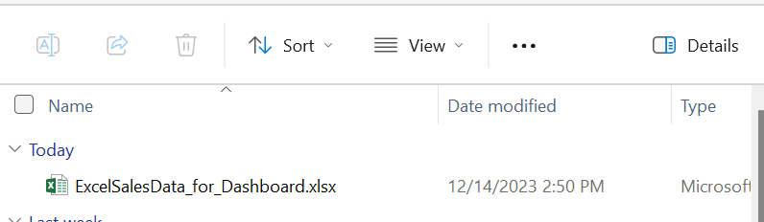

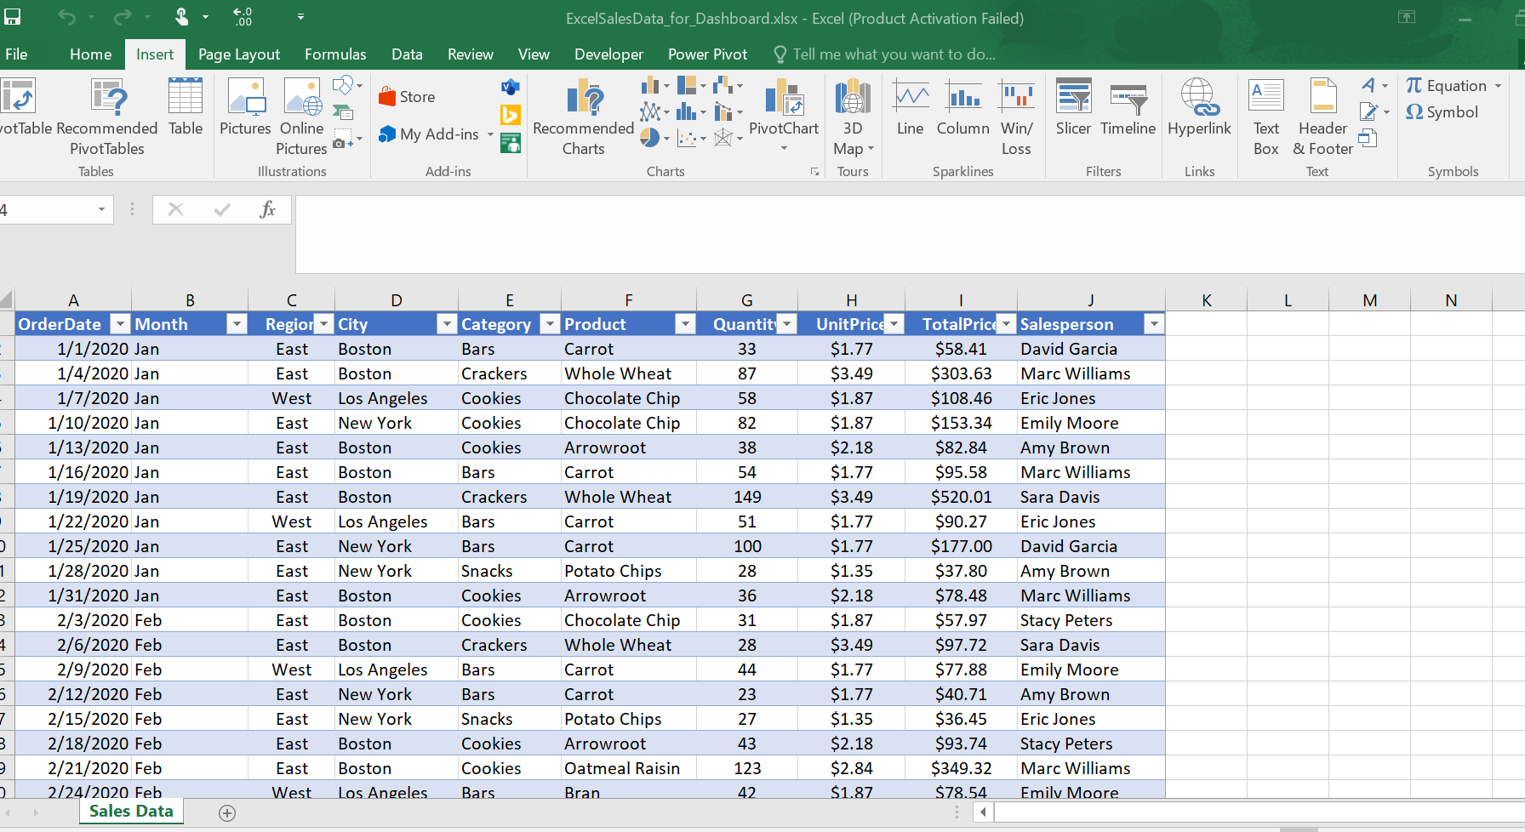

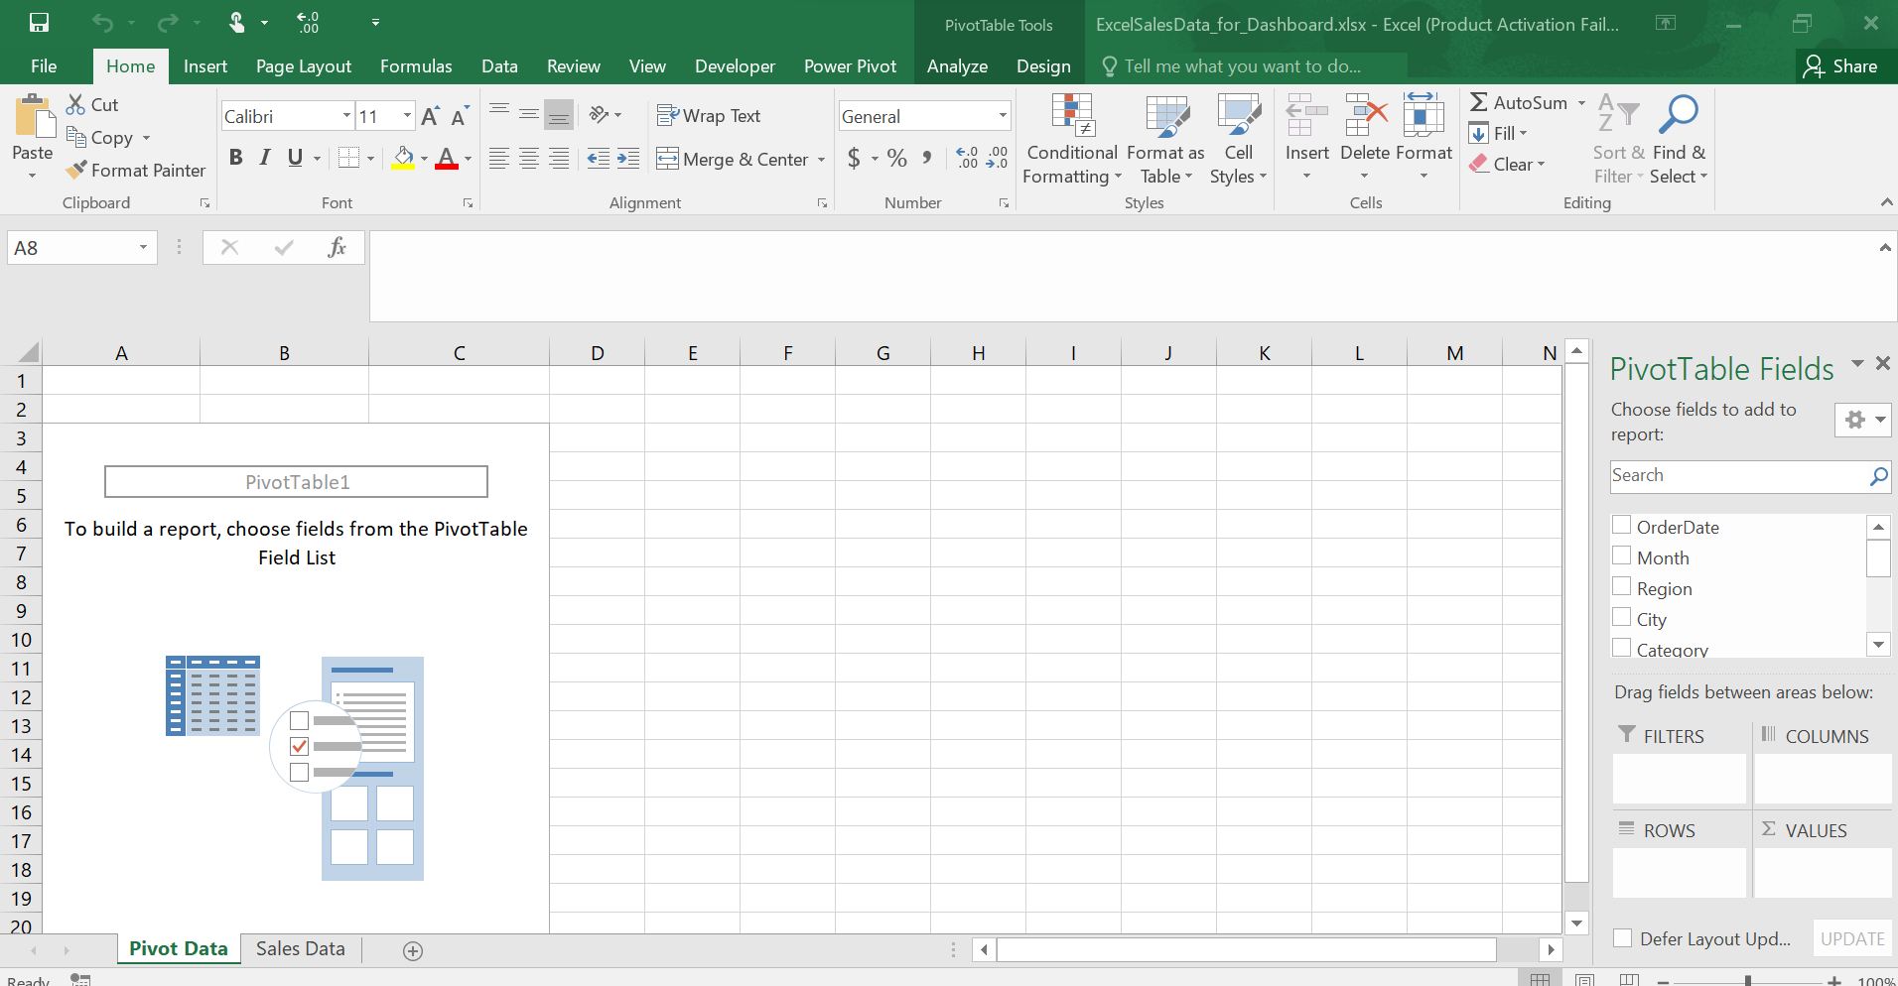

2) Create and format a line chart in Microsoft Excel to represent sales profit by month. (Provide a screenshot of the pivot table and line chart.)

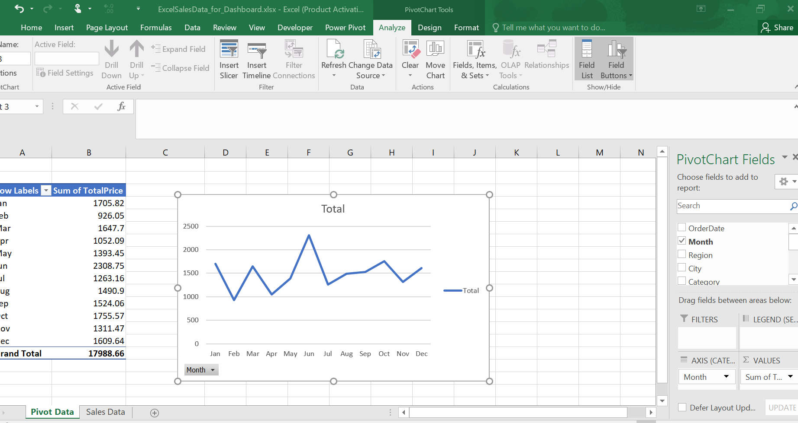

3) Create and format a bar chart in Microsoft Excel to represent sales profit by salesperson. (Provide a screenshot of the pivot table and bar chat.)

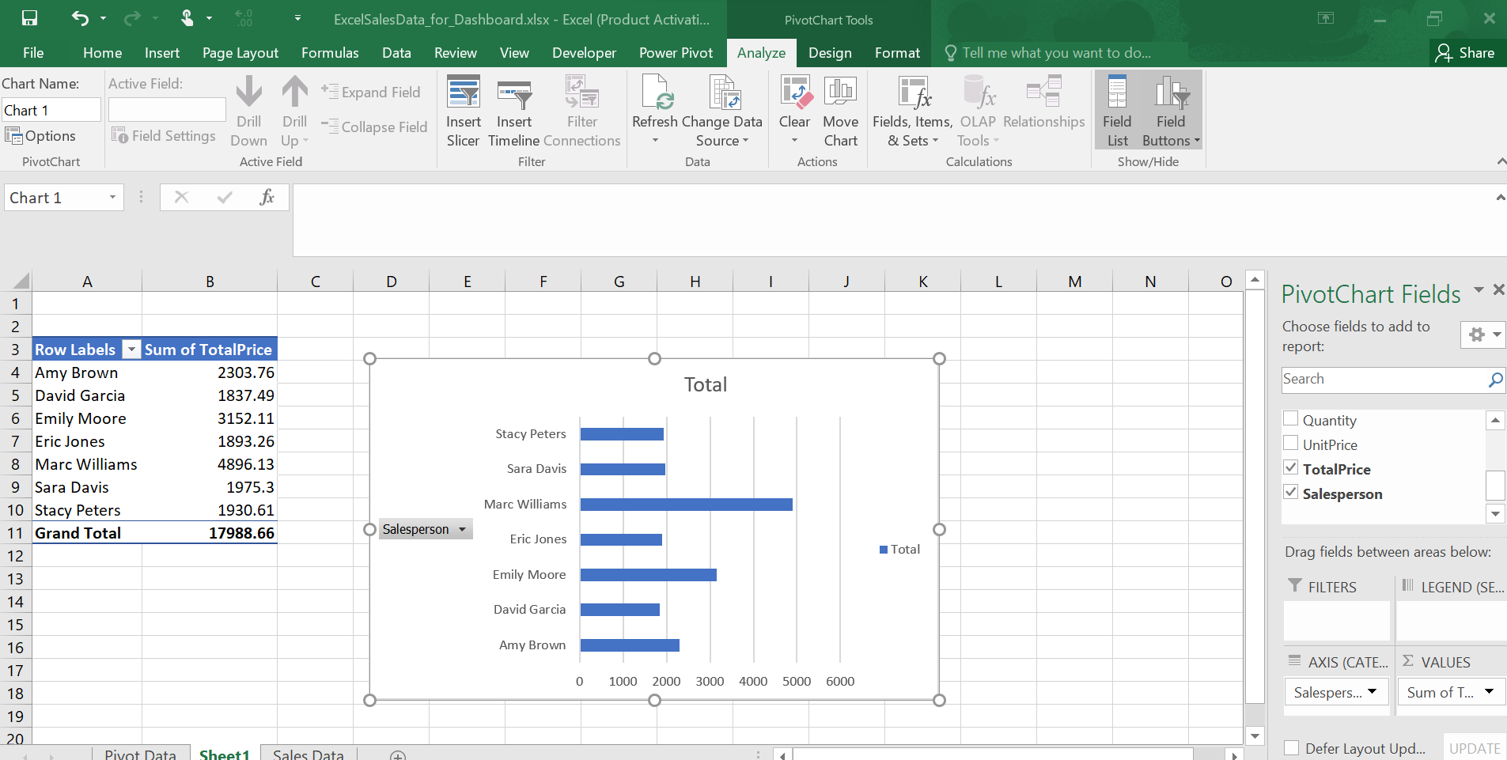

4) Create and format pie charts in Microsoft Excel to represent sales percentages by product category and city. (Provide a screenshot of the pivot table and pie chart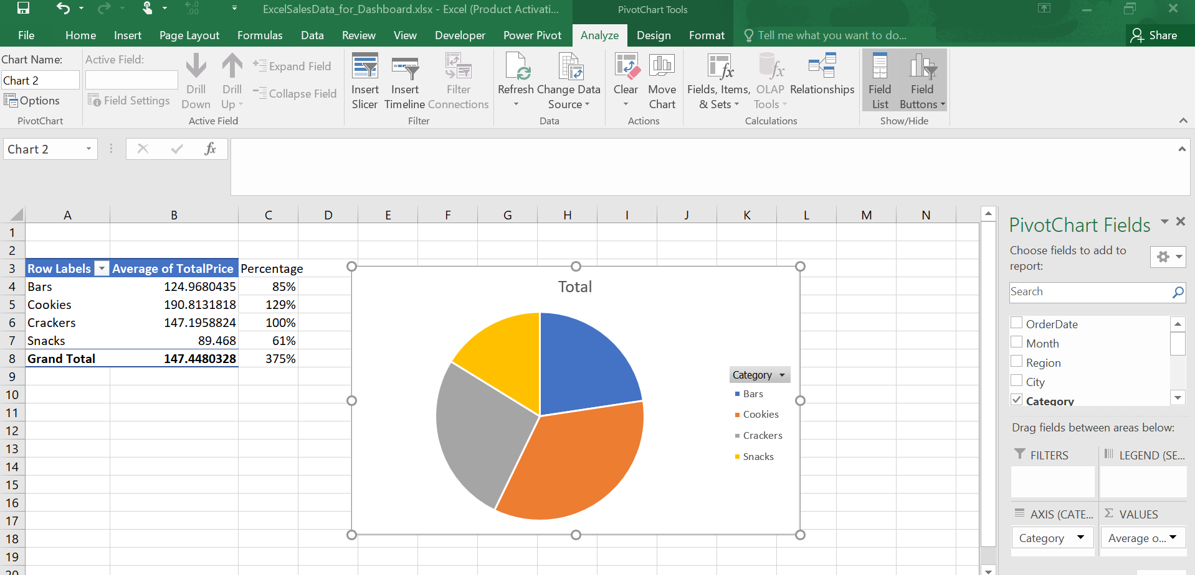

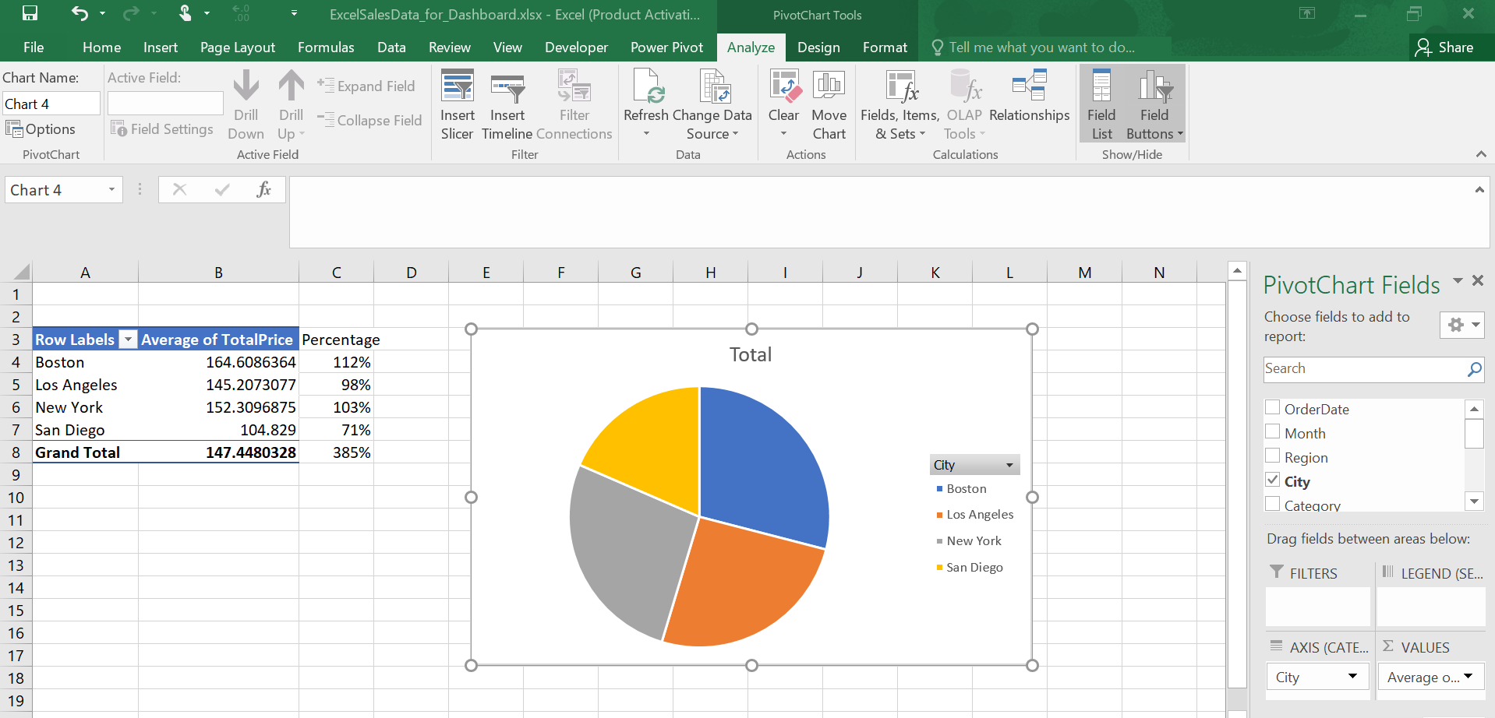

5) Create a dashboard in Microsoft Excel containing charts and tables. (Provide a screenshot.)

